IBM 7094
The 7094 was IBM’s most powerful scientific computer in 1963. An “upgrade” from the IBM 7090, the 7094 was 1.4 to 2.4 times faster than its predecessor ⎯ it could perform 500,000 logical decisions, 250,000 additions or subtractions, 100,000 multiplications, or 62,500 divisions in one second. It had hardware to do double-precision floating-point arithmetic.
The computer gained considerable I/O bandwidth from its separate data channels with direct memory access, and so it was also used to run business and general-purpose applications. The 7094 had an operating system called IBSYS, and FORTRAN and COBOL compilers.
A typical system cost $3,134,500. IBM stopped selling them in 1969.
Sources: C. Gordon Bell, et al. Computer Structures: Readings and Examples. New York: McGraw-Hill, 1971. pp. 515-523
Manufacturer: IBM Memory technology: magnetic core
First introduced: 1963 Memory size: 32K 36-bit words
CPU technology: transistor Cycle time: 2 microseconds (0.5 MHz)
Charles Basche, et al. IBM’s Early Computers. Cambridge, MA: MIT Press, 1986. p. 449
IBM 7094 Principles of Operation. IBM Systems Reference Library, 1962
IBM 7090/7094 IBSYS Operating System. IBM Systems Reference Library, 1964
IBM 7090/7094 IBSYS Operating System Version 13 FORTRAN IV Language. IBM Systems Reference Library, 1968
http://www.multicians.org/thvv/7094.html
http://www.multicians.org/mga.html
http://www.ibm.com/news/ls/1999/07/articles/sidebar_13.phtml

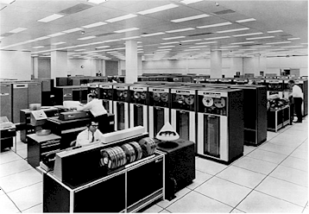
Photo by IBM (http://www.ibm.com/news/ls/1999/07/photoarchive/photoarchive_13.phtml)

