IBM 1620 Model 1
The IBM 1620 Model 1 was a very popular scientific computer during the early 1960s, and yet it didn’t know how to add! To keep its cost low, it had neither general data registers nor a conventional arithmetic unit. To add or multiply, the machine consulted tables in its memory.
The 1620 was a digital computer that it did its calculations in base 10 with variable-length operands. Programmers could code in FORTRAN, SNOBOL, and assembly languages. The machine was used in colleges and universities and for industrial process control applications.
IBM had delivered over a thousand 1620 Model 1 systems by the end of 1963.
Sources: Emerson Pugh, et al. IBM’s Early Computers. Cambridge, MA: MIT Press, 1986. pp. 508-510
Manufacturer: IBM Memory technology: magnetic core
First introduced: 1959 Memory size: 20K to 60K 6-bit characters
CPU technology: transistor Machine cycle time: 20 microseconds (0.05 MHz)
William J. Claffey. Principles of Programming the IBM 1620 Computer. Belmont, CA: Dickenson Publishing., 1968
Daniel N. Leeson, et al. Basic Programming Concepts and the IBM 1620 Computer. New York: Holt, Rinehart and Winston, 1962
http://www.acc.chula.ac.th/bundhit/IBM1620.html
http://www.transy.edu/homepages/miller/home/1620.htm

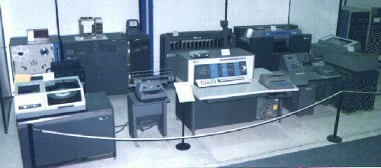
Technology Museum of Thessaloniki

