IBM 1130
The IBM 1130 was a desk-sized computer designed for small-scale general-purpose and scientific applications. At its original release, IBM provided more than 50 programs for mathematical, statistical, and engineering applications. FORTRAN programs written for the 1130 could also run on the IBM Sytem/360 series. Programmers could also code in the RPG and assembly languages.
The machine had removable one-megabyte disk cartridges. It could also support punch card and paper tape equipment, line printers, plotters, an optical mark page reader, disk storage packs, and graphical display units. An 1130 computer could also function as a remote processor terminal for a 360 computer.
Sources: Emerson Pugh, et al. IBM’s 360 and Early 370 Systems. Cambridge, MA: MIT Press, 1991. pp. 497, 587
Manufacturer: IBM Memory technology: magnetic core
First introduced: 1965 Memory size: 4K or 32K 16-bit characters
CPU technology: semiconductor Memory cycle time: 3.6 microseconds (0.28 MHz)
C. Gordon Bell, et al. Computer Structures: Readings and Examples. New York: McGraw-Hill, 1971. p. 399
Original IBM press release at http://www.shubs.net/1130/1130Release.html
IBM 1130 Functional Characteristics (System Reference library) at http://www.shubs.net/1130/functional/index.html

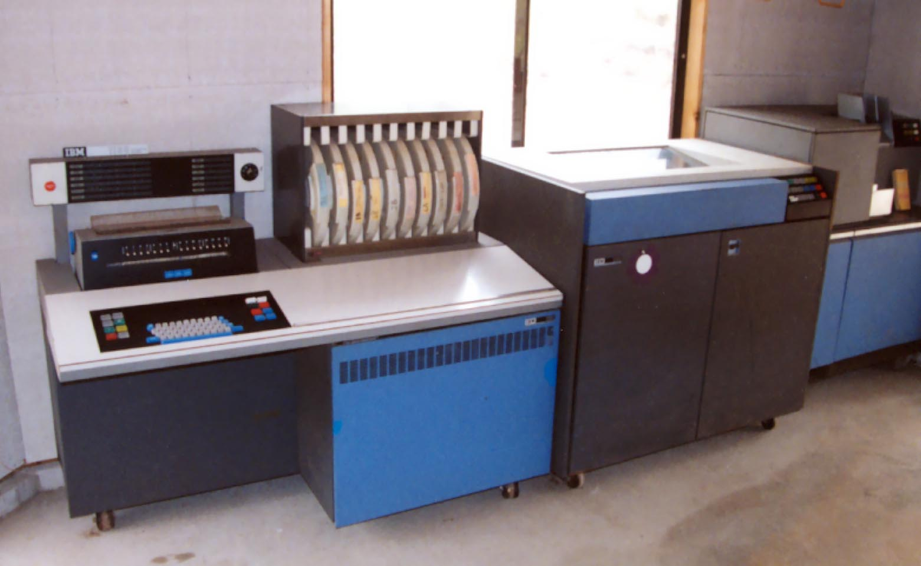
http://bigoakhill.home.comcast.net/ibm/

