Grinding 729 tape drive capstans by Grant Saviers, February 8, 2008

It has been difficult achieve the specified tape start times on the first 729 being restored on the 1401 system. Many efforts at adjusting the prolays have not yielded operation to specification. It was noted that the supply (backwards) and takeup (forward) capstans showed wear grooves the width of the tape, as is usual for “experienced” capstans. Measurements showed these grooves to be 0.003 to 0.004” less in diameter than the rubber at the edge of the capstan. For reference, two samples of 10.5” reel 6250 generation tapes I own averaged 0.0016” overall thickness.

Worn capstan from first refurbished 729.
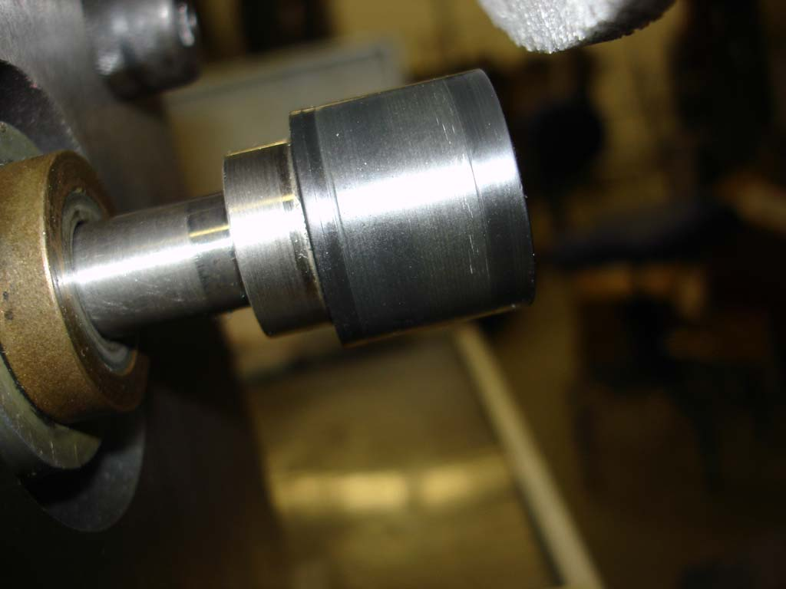

The motors were removed from the 729 and taken to Grant’s shop for evaluation and an effort to grind the capstan rubber flat. Allen found that the capstans were easily removed, as they were held in place with a single right hand threaded screw. The capstans have a taper to fit the motor shaft. This taper provides fairly accurate alignment of the centers of rotation. Given that the capstan motors have opposite rotations, and that the retaining screws are both RH, it is apparent that the IBM engineers intended the taper to be a “jam” taper, capable of transmitting the motor torque without slipping. Allen noted that witness marks were on one of the capstan and its shaft, indicating that IBM ground the capstan rubber while it was attached to the motor. An email from Van Gardner indicated that for many years IBM had no part number for capstans and would only supply a motor plus capstan assembly as a spare part, which supports this view of the manufacturing process.

First, I observed that both motors seemed identical in all respects, same part numbers, same power cable pin outs, etc. Therefore, the tape drive wiring causes the motors to spin in opposite directions. The motors are rated 1500 rpm for 50hz operation, 3 phase delta, 240 volts.

Motor name plates (same for supply motor).
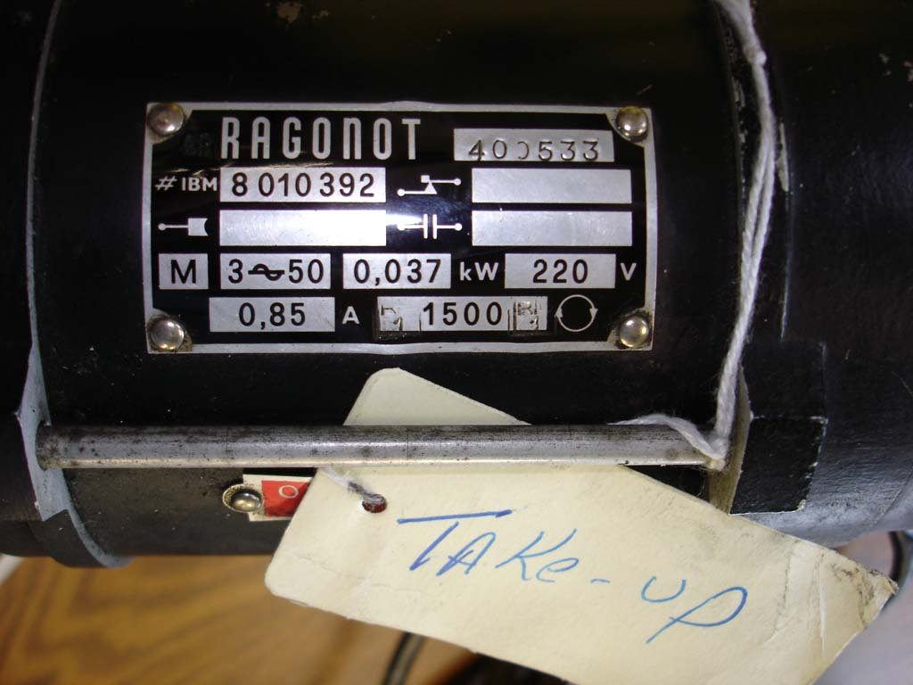

My first test was to check if they would run ok on my shop power of 60hz, 3 phase delta, 240 volts. This test was successful EXCEPT when the motor shaft returned to its home position (the motor rotor at rest position is held back with a spring and when power is applied the stator magnetic field pulls the rotor forward into the tape path position). The retraction on one motor was very rough, much banging and clunking. Allen disassembled this motor and we discovered that without the capstan attached the rear of the rotor could contact the rear bell of the motor housing. Some of the aluminum fan fins cast into the rear of the rotor were bent, but were straightened without difficulty or apparent damage. Lesson: DO NOT OPERATE CAPSTAN MOTORS WITHOUT THE CAPSTAN ATTACHED. The other motor did not have this problem when operated without the capstan. We did not disassemble this motor. I find it unusual that IBM would make a motor that damaged itself without a capstan present and suspect that an internal spacer to prevent extreme rearward motion of the rotor is missing in the one motor, but that is speculation at this point.

Because of the ability of the motor to move in and out of the tape path, thrust bearings are on both ends of the motor housing. The rear ones appear to be a soft graphite like material. The rear bearing engages the front surface of an aluminum disk held by a taper pin. It appears that the graphite thrust bearing is press fit into the motor end bell. They appeared to be in acceptable condition. However, it would be wise to research them, as replacement at some point will be required. It is necessary to remove the rear disk to disassemble the motor. The shaft bearings are bronze sleeve bearings.

The disassembled motor also operated with noticeably more vibration (being synchronous motors both spun at 1800 rpm on 60Hz). Initially, I thought this might be an 1800 rpm only problem since they were likely balanced at 1500 rpm. However, examination of the shaft showed scoring of the shaft in a candy cane spiral from the extend/retract operation and a 180 degree significant wear pattern on the rear of the shaft in the extend position. Lubrication of the capstan motors should be a regular PM procedure. This motor (take-up – forward) also receives significantly more use, so one strategy if the runout/vibration is determined to be a problem is to swap supply and take-up motors.

I purchased a cast iron ground angle plate 6 x 6 x 6” with double webs, machined the back of the plate flat for the motor mounting ears, bored a hole for clearance of the front taper on the motor, and drilled three mounting holes for the ears to be bolted with ½” bolts to the plate. I milled away the webs where they would interfere with mounting the motor. After completion of the machining I checked the modified angle plate with a cylinder square and determined that the plate remained square to its original specified 0.0005” per 6”.

Machined angle plate fixture to hold the motor.
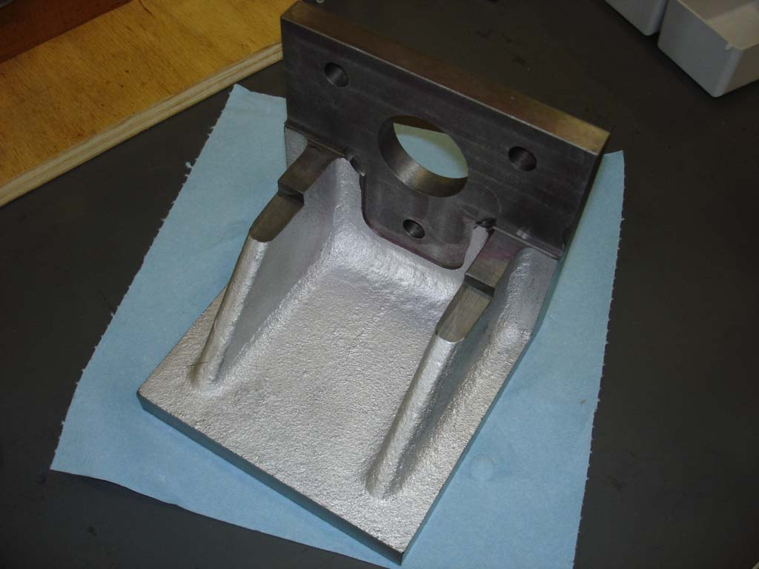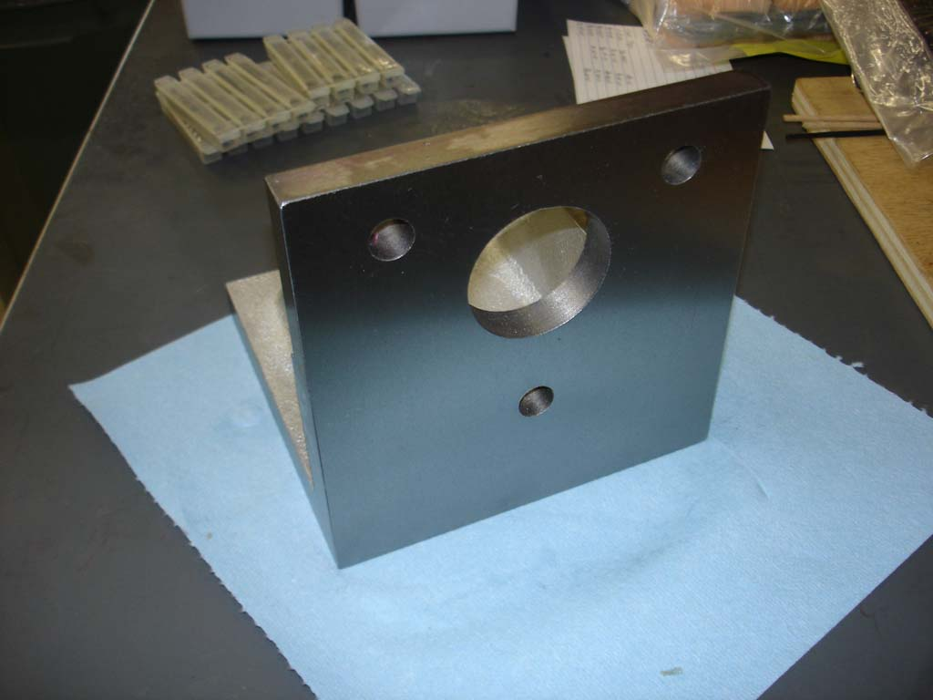

Having no experience in grinding rubber, I researched the procedure on the web. Special dimpled CBN or diamond grinding wheels are used for production grinding and for limited grinding, an open structure aluminum oxide can be used. Narrow width wheels are recommended to minimize wheel to rubber contact and heat build up. Fortunately, I had such a wheel, Radiac POR-OS-WAY 9A46H2VOS ¼” thick x 7” diameter. The occasion of this project caused me to check out and tune up my Chevalier 6 x 18 surface grinder magnetic chuck flatness and squareness. Satisfied that everything was adequately true and square, I mounted the grinding wheel and single point diamond trued it.

I also built a wiring harness to convert my standard 20 amp three phase outlet to the motor connector. I purchased a 2.5 amp three phase breaker and placed this in the harness as the motor on/off switch and to protect the motor. The motor connector has 0.156” on center pins that are very short and I machined a Molex type connector body so its female pins could grip the motor connector pins
.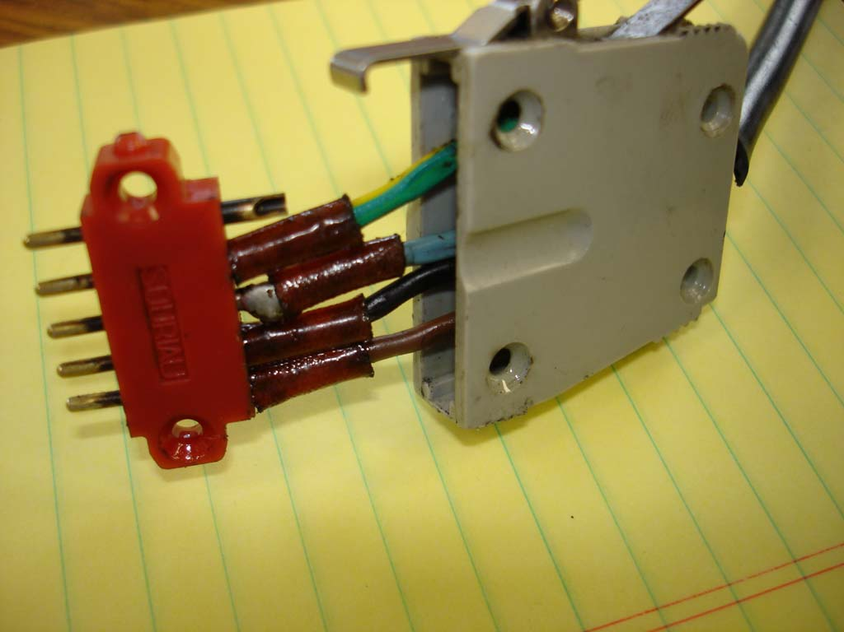

The motor was mounted to the angle plate and squared to the table with parallels. The center of rotation of the motor and grinding wheel were vertically aligned to minimize any chance of a taper being ground into the capstan.

Grinding setup, second capstan. Note light wheel loading.
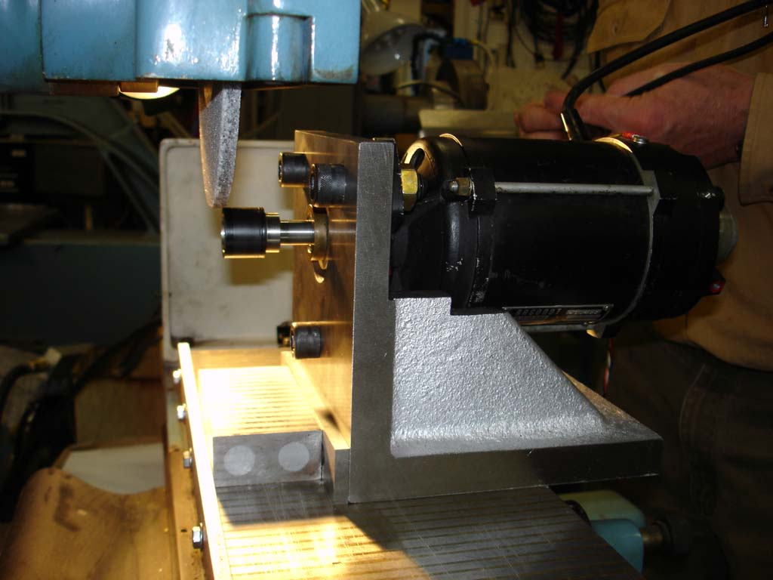

The capstans were mounted to the shafts and witness marks were verified or placed. Each motor had 60Hz power applied so the capstan was ground true to its mounted center of rotation.

Adjusting downfeed 0.0005” each pass
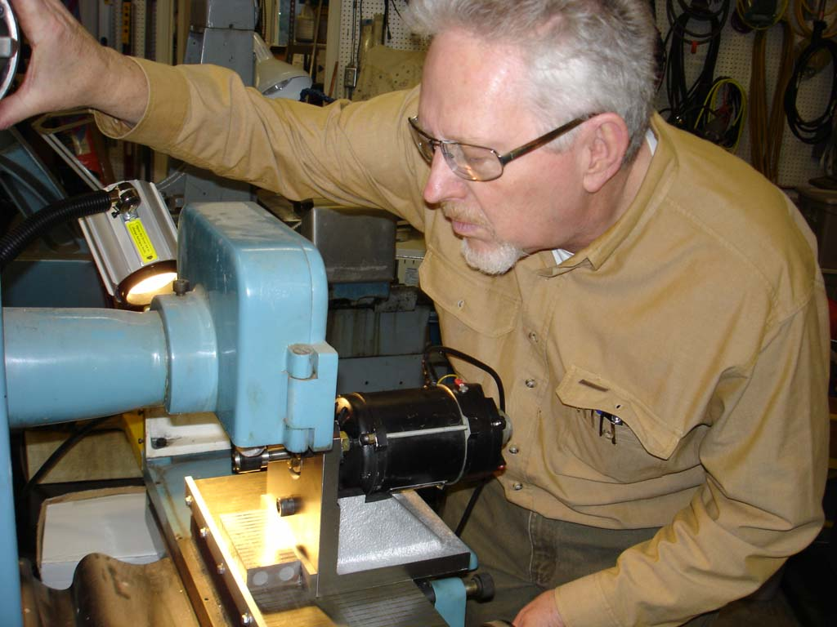

For the first effort on the supply capstan, I lowered the wheel 0.0005” per pass with a fairly rapid Y (cross) axis traverse. After removing about 0.002” most of the tape groove shoulder was removed but some glazed and flat spots remained. Another 2 passes of 0.0005” cleaned these up, so this capstan is now about 0.006” in diameter undersize prior to restoration.

For the take-up capstan, I initially was more aggressive at 0.001” per pass and discovered that it was significantly softer than the supply capstan. Most likely it had been replaced more frequently and thus was a later model and not as old as the supply side. In this case it required 0.003” of depth to remove the groove shoulders and there were no visible glazing or flat spots to remove. I would estimate the durometer to be about the same as a new stop capstan I tested at A80 or so versus the first capstan that felt moderately harder.

Both capstans were measured by micrometer to be flat across their width with no taper, within the limits of feel with a .200” diameter micrometer face against a rubber surface.

The grinding wheel was inspected for rubber loading, which was light. However, it would probably be prudent to dress the wheel after grinding every two capstans.

The capstan motors were returned to Allen for installation on the 729.

Conclusions:

Pending testing results in the drive it appears that the tooling and process will refurbish capstan rubber of various vintages. The tooling took about a day and a half to design, procure, and fabricate. It takes about ten minutes to grind each motor assembly with this fixturing.

A finished capstan, supply side
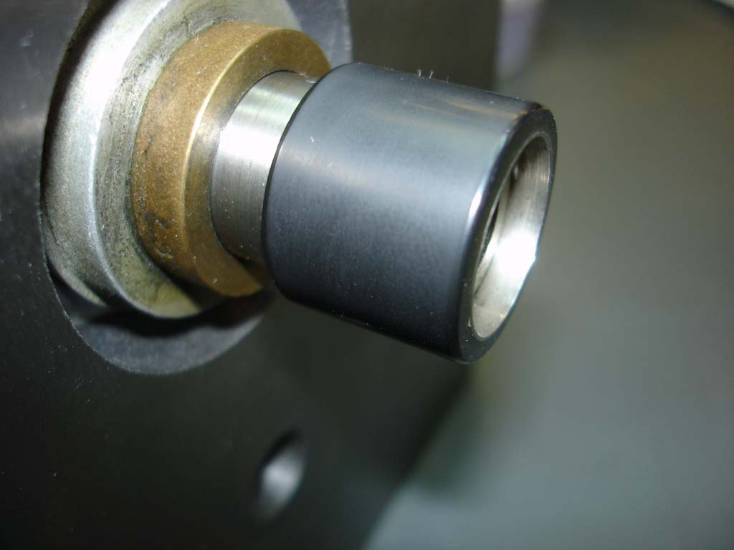

Questions:

How did IBM get the same tape speed on 60 Hz 729’s? Is the tape speed the same for 50 and 60 Hz drives? Some motor-generator sets for converting 60 to 50 Hz use a 12 pole motor and 10 pole generator. That option isn’t possible at 1800/1500 rpm. Are the capstans for 60 Hz 5/6 the diameter of 50 Hz versions? This has impact on what can be interchanged between 50 and 60 Hz tape drives.

