IBM 650
The IBM Type 650 Magnetic Drum Calculator was a “small” stored-program office computer. The attached punched-card unit was controlled by plugboards for added I/O flexibility. At its release, the 650 was competitive in both price and performance, and it became popular for business data processing applications. It was reliable and easy to use. Programmers coded in assembly language using the Symbolic Optimum Assembly Program (SOAP).
The 650’s drum was 4 inches in diameter, 16 inches in length, and spun at 12,500 RPM. The machine represented each decimal digit using the 7-bit biquinary system.
IBM sold nearly two thousand 650 computers and manufactured the last one in1962.
Sources: Emerson Pugh, et al. IBM’s Early Computers. Cambridge, MA: MIT Press, 1986. pp. 165-172
Manufacturer: IBM Memory technology: magnetic drum
First introduced: 1954 Memory size: 1000 or 2000 10-digit words
CPU technology: vacuum tube Average memory access time: 2.4 milliseconds (0.0004 MHz)
C. Gordon Bell, et al. Computer Structures: Readings and Examples. New York: McGraw-Hill, 1971. pp. 220-223
Ned Chapin, An Introduction to Automatic Computers. Princeton, NJ: D. Van Nostrand Company, Inc., 1957. pp. 267-268
650 Magnetic Drum Data-Processing Machine: Manual of Operation. IBM, 1955 at http://www.piercefuller.com/collect/650man/
http://www.columbia.edu/acis/history/650.html
http://www.mta.ca/~amiller/ibm650/ibm650.htm

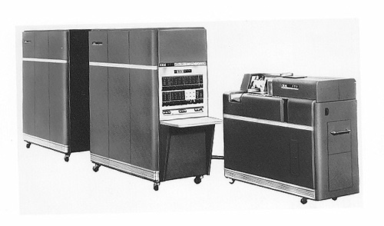
http://www.computer.org/history/development/graphics/54ibm.jpg

